**Assignment – 1**

**Student Name:** Vivek Kumar  **UID:** 21BCS8129

**Branch:** BE-CSE (LEET) **Section/Group:** 809/A

**Semester:** 4th **Date of Performance:** 12/03/2022

**Subject Name:** Principles of AI  **Subject Code:** 20CST-258

**1. Aim/Overview of the practical:**

Which algorithm does Facebook use for face verification and how does it work?

**2. Task to be done/ Which logistics used:**

* Algorithm Flow chart.
* Steps of Working Principle of the Algorithm.

**3. Theories:**

Facebook’s researchers have built DeepFace, an algorithm that can pick a face out of a crowd with 97.25% accuracy. The trouble with most face recognition systems is that if the faces are slightly off-center in the photo the software will struggle to find a match. Yaniv Taigman and colleagues at Facebook's AI lab found a way round this problem. They created a 3D model of a face from a photo that can be rotated into the best position for the algorithm to start matching. They then used a neural network that had been trained on a massive database of faces to try and match the face with one in a test dataset.

DeepFace tool that makes use of the deep learning algorithms for the face verification that lets in the photo tag pointers to you whilst you add a picture frame on Facebook. The deep face identifies the faces withinside the virtual pics the use of neural community models. The operating of DeepFace is given in underneath steps:

* It first scans the uploaded pics. It makes the 3D version of the picturegraph, after which rotate that picturegraph into one-of-a-kind angles.
* After that, it begins off evolved matching. To suit that picturegraph, it makes use of a neural community version to decide the high-degree similarities among different pictures of a person. It tests for the one-of-a-kind capabilities inclusive of the space among the eyes, the form of the nose, eyes colour, etc.
* Then it does the recursive checking for sixty-eight landmark testing, as every human face includes sixty eight particular facial points.
* After mapping, it encodes the picturegraph and searches for the statistics of that person.

**4. Flowchart:**

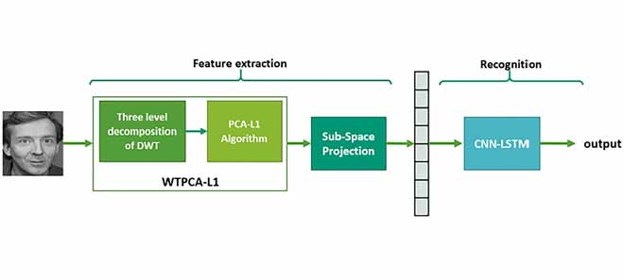

**Learning outcomes (What I have learnt):**

**1.** Studied about the face Recognition System which is DeepFace.

**Evaluation Grid (To be created as per the SOP and Assessment guidelines by the faculty):**

|  |  |  |  |
| --- | --- | --- | --- |
| Sr. No. | Parameters | Marks Obtained | Maximum Marks |
| 1. |  |  |  |
| 2. |  |  |  |
| 3. |  |  |  |
|  |  |  |  |